Riphah International University
Gulberg Green Campus Islamabad
Faculty of Computing (WISH)



Name: Anisha Rehmat.
Sap ID: 78019.
Submitted To: Mam Nayab Khalid
Submitted by: Anisha Rehmat.

Supervision and Coordination

Miss Hira Jafar
Lecturer
Faculty of Computing

Lab Designers

Miss Nayab Khalid
Teaching Fellow
Faculty of Computing

Lab Task 4

Learning Outcomes:

Demonstrate Array & ArrayList Operations: Differentiate between fixed-size primitive arrays and dynamic ArrayList collections, including declaration, initialization, and element manipulation.
- Apply Enhanced Iteration: Utilize the Java for-each loop to traverse arrays and collection frameworks efficiently.
- Utilize Wrapper Classes: Apply Java Wrapper classes (Integer, Double, Character) to convert primitive types into objects for use in collection classes via autoboxing and unboxing.
- Master String Processing: Employ Java String methods (such as .length(), .charAt(), .substring(), .indexOf(), and .split()) to perform text manipulation and string processing tasks.

Lab Tasks

Task 1_ Student Marks Management system
Write a Java program to store the marks of five students using an ArrayList<Integer>. Use an Enhanced For Loop to display all the marks, calculate and display the total and average marks, and find and display the highest mark.

Input:-
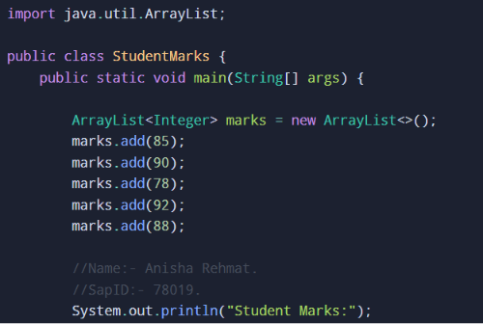
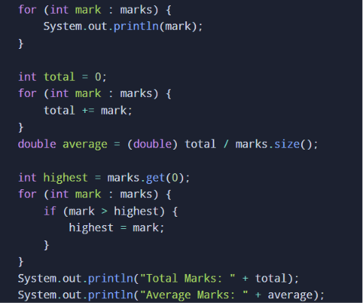
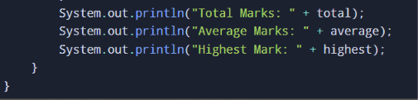

Output:-

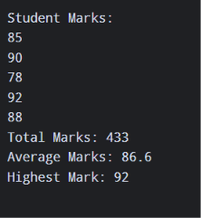

Task 2_Student Name String Processing
Write a Java program that takes a student's name as a String and performs basic string processing. The program should display the original name, its uppercase and lowercase forms, the total number of characters, the first character using charAt(), and whether the name contains the letter "a".

Input:-
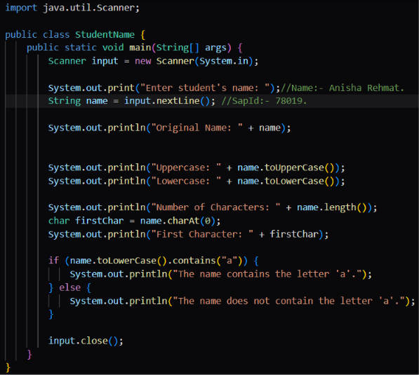

Output:-

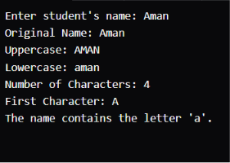

Task 3_ Character processing and Type Identification
Write a Java program that takes a single character from the user and stores it in a char variable. Display the entered character and its corresponding integer/Unicode value. The program should also determine whether the character is a digit, an uppercase letter, or a lowercase letter, and display the appropriate message.
Input:-
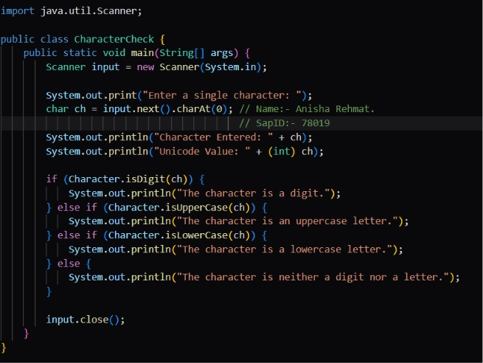

Output:-
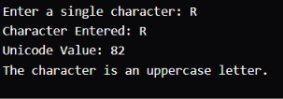

___________ The End _____________

